Highlights!
- Beautiful trail course at Coe-Brown!
- Tons of free homemade goodies!
- Free Nike Dri-Fit shirts to first 125 entries!
- Tons of great awards!
- Wonderful door prizes and raffle items!
- 2.5K walk!
- 400-meter kids’ fun run!
- Professional timing services!
- Coe-Brown XC’s famous Fun Spots!
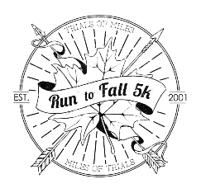
Awards
Run to Fall 5K: Cash awards will be given to top 3 male and female overall finishers, master winners, and special awards to top male and female finishers in age groups 13-19, 20-29, 30-39, 40-49, 50-59, 60-69, 70+
XC Challenge: Special awards for teams in these categories: Open Female/Male, Mixed
Date: September 11, 2016
Time: 5K/2.5K at 10:00 am (registration at 8:00 am), kids fun run immediately following
Please make checks payable to “Coe-Brown Cross Country”
Run to Fall 5k
Attn. Tim Cox
Coe Brown Northwood Academy
907 First NH Turnpike
Northwood, NH 03261
Name (First and last):________________________ Street Address:_____________________________ City/State/Zip:______________________________
Age (day of race):___ T-shirt (circle) S M L XL
Team:_____________________________________
Email:_____________________________________
Amount Enclosed:_______ ($17 pre-reg/received by Sept. 8 )
Start and Finish: Coe-Brown Academy
Pre-Registration: $17 (must be received prior to September 8, 2016)
Race Day Registration: $20
Team Registration: Please indicate team name on all forms
Questions: Call Allison Pratt (603-988-5740) or Tanner Richards (603-988-3407) or email runtofall5k@gmail.com
Directions:
From Concord: Rte. 4 East ~10 miles to Epsom Traffic Circle. Continue East on Rte. 4 ~9 miles. CBNA will be on the right. The Athletic Complex is on the left. Whew! You made it! Registration will be right in front of Smith Hall.
From Portsmouth: Rte. 16 North to exit 6W, Rte 4 West to Lee Traffic Circle. Continue on Rte. 4 West~12 miles. CBNA will be on the left. The Athletic Complex will be on your right. Congratulations, you are now at the race!
Release and Waiver:
In consideration of this entry being accepted, I hereby for myself, heirs, executors, administrators, waive and release all rights and claims for damage I may have against the Run to Fall 5K and all sponsors, its agents, representatives, successors, for all injuries suffered by me at said event or while traveling to and from there grant permission to all the foregoing to use any photographs, motion pictures, recording or other record of this event for any legitimate purposes.
Signature of participant (or guardian if under 18)
_____________________________________________ Date:___________

A SPECIAL THANKS TO OUR HALF MARATHON & 5K SPONSORS!

NORTHWOOD VETERINARY HOSPITAL Northwood, NH 603-942-8368
UNDERWOOD ENGINEERS
Portsmouth + Concord, NH 603-436-6192
NE TRAFFIC CONTROL SERVICES, INC
Epsom, NH 800-640-8212
DEERFIELD FERNS
Deerfield, NH 603-556-1093
RYAN CONSTRUCTION MANAGEMENT
Rochester, NH 603-728-8955
SCARPONI ELECTRIC
Rochester, NH 603-332-5011
NORTHWOOD GARAGE
Northwood, NH 603-942-8882
ANYTIME FITNESS
Northwood, NH 603-942-6027
FK BASSETT & SON PLUMBING & HEATING
Northwood, NH 603-942-5026
GEORGE CALEF’S FINE FOODS
Barrington, NH 603-664-2471
J&B AUTO SALES
Northwood, NH 603-942-5501
JOHNSON’S SEAFOOD & STEAK
Northwood, NH 603-942-7300
MACCALLUM’S BOATHOUSE
Epsom, NH 603-736-4750
MCBRIDE’S WATER ADVANTAGE, LLC
Epsom, NH 603-736-4470
MEYER FAMILY DENTISTRY
Northwood, NH 603-942-8000
NORTHWOOD RV
Northwood, NH 603-942-8466
RUNNER’S ALLEY
Portsmouth, NH 603-430-1212
UMAMI
Northwood, NH 603-401-2844
MA’S AN MINE
Northwood, NH 603-942-6024
PERFORMANCE HEALTH SPORT & SPINE THERAPY
Concord, NH 603-724-2297
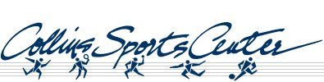
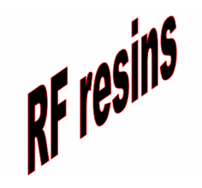

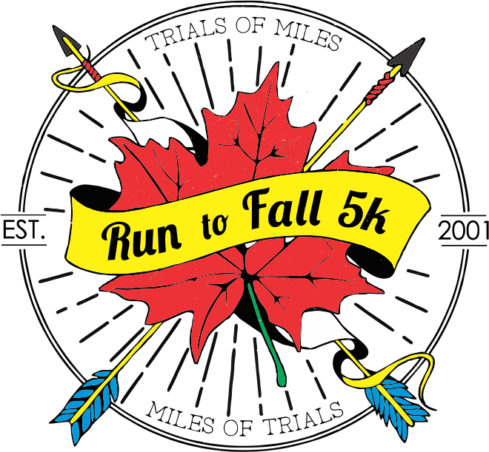
Race starts at 10:00 am
Sunday, September 11, 2016
Registration at 8:00-9:45 am
Runtofall5k.weebly.com
Sign up to support CBNA XC/TF!

